1. Executive Summary
   1. Abstract of game story
      1. Player hangs out with friends, they discover a buildings while out walking. Player escapes a sudden rain into building before others, and ends up getting locked in alone. Doors are locked, and windows are barred. A flashlight found shortly after entrance is the only object the player can use to help. This is illustrated in the storyboard given in the appendix below.
   2. Concept
      1. The overall genre of the game is made to combine the horror and humor genres. The meme aspects of the enemies provides the humor and the setting itself provides the horror component.
2. Game Play Look and Feel
   1. Appearance
      1. The game is given a top-down view of the player’s map in a retro gaming style. It takes place in an abandoned insane asylum setting. The various rooms are filled with wheelchairs, medical equipment, and other various items appropriate for the building. An image of the first level can be seen below.

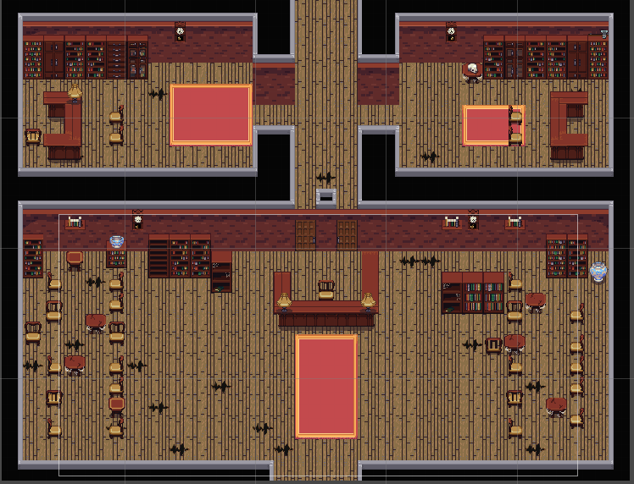

First level layout

* 1. Player roles and actions
     1. The player’s role in this game is to find the way out of the asylum. The player is given the goal to find a key per each level to open the exit door. The player is also given a flashlight, which attracts enemies to their location, but also provides the player with a way to see to navigate through the building. The player is also depicted in the 32-bit style as the rest of the game, as seen below.



Player

* 1. Strategies and motivations
     1. Players are motivated to continue navigating the levels to find a way out. In getting past the enemies, the player may choose to move past them without activating their flashlight or they may also use the light to move the enemies away from certain locations to enable their continued progress.
  2. Level summary/story progression
     1. The first level starts with the player in the lobby of the asylum. Within the first level, there are also patient intake rooms which the player must search to find the key.
  3. Audio
     1. Sound effects add to the overall ambiance of the game to give the player an uneasy feeling. Some of the effects include labored breathing, floors creaking, footsteps and windows rattling. These all help to solidify the horror environment.
  4. Lighting:
     1. The lighting elements within the game also play a big role when it comes to establishing the horror genre context. When the player’s flashlight is turned off, the lights will flash briefly to guide the player. While the player’s flashlight is turned on, it allows the player to see their path as long as their flashlight has enough battery power.
  5. Enemies
     1. General Enemies
        1. The enemy’s goal is to keep the player from passing onto the next level and ultimately reaching the exit. The enemies in this game are based upon popular memes, as stated above. Specifically, the first level depicts a moth enemy which is drawn to the light. The moth enemy can be seen below.



Moth Enemy for Level 1

* + 1. Boss Battles
       1. As the player cannot directly engage with the enemies, the boss battles will consist of a puzzle that must be completed in order to advance. These battles occur at the end of a level and the player must defeat them in order to advance to the next level. These battles are presented in a cut scene fashion, with the player’s goal given to them in a text dialogue.
  1. Features
     1. Another feature that adds to the overall playability of the game is that there are new enemies each level. By changing the enemies, it allows the player to find new ways to defeat them. Another feature is that walking through certain doorways causes more enemies to spawn within the level, so the player must be mindful of their movements. Lastly, as the flashlight’s battery power is not infinite, if a player spends too long in one location, it could also kill them as they cannot see where to go next.

1. Development Specification
   1. Hardware Used
      1. MacBook Pro (Retina, 13-inch, Late 2013)  
         macOS High Sierra (10.13.6)  
         Processor: 2.8 GHz Core i7  
         Memory: 16 GB 1600 MHz DDR3  
         Graphics: Intel Iris 1536 MB
      2. MacBook Pro (13-inch, Mid 2012)

macOS High Sierra (10.13.6)

Processor: 2.5 GHz Intel Core i5

Memory: 16 GB 1600 MHz DDR3

Graphics: Intel HD Graphics 4000 1536 MB

1. Developed for
   1. Mac, PC, and Linux platforms
   2. Software
      1. Unity 2018.2.0f2
      2. Visual Studio Community 2017
      3. Tiled
      4. Tiled2Unity
   3. Algorithm Style
2. Appendix
   1. Storyboard

